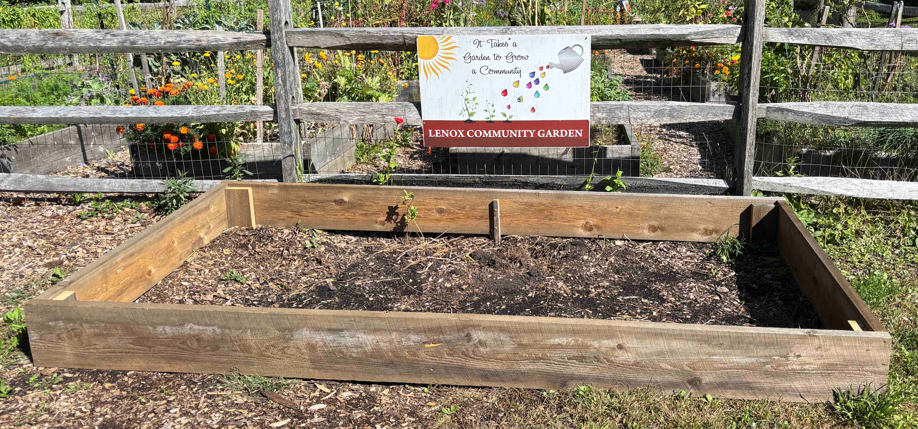
Academy Garden Club of Lenox
2025 – 2026 Signup Sheet

Pollinator Garden Maintenance

Please sign up for a week or two to help the Pollinator Garden look good. Your job includes dead heading, weeding and watering. Please bring container for the weeds/dead heads. Water is from the water butt behind the church.
If you have any concerns please call Kathy DeVylder 613-1769 (please do not call the DPW).

Week | Name | Phone #
June 2 - 7
June 9 - 14
June 16 - 21
June 23 - 28
June 30 - July 5
July 7 - 12
July 14 - 19
July 21 - 26
July 28 – August 2
Aug 4 - 9
Aug 11 - 16
Aug 18 - 23
Aug 25 - 30
Sept 1 - 6
Sept 8 - 13
Sept 15 - 20
Sept 22 - 27
Sept 29 - Oct 4
Oct 6 - 11

